

Credit Card Data Insights

Report

**Contents**

|  |  |  |
| --- | --- | --- |
| **Sr.No.** | **Section** | **Page No.** |
| **1.** | **Title** | **3** |
| **2.** | **Objective** | **3** |
| **3.** | **Executive Summary** | **3** |
| **4.** | **Observations** | **4** |
| **5.** | **Dashboard Overview** | **9** |
| **6.** | **Conclusion: Insights, Recommendations, Future Improvements** | **11** |
| **7.** | **Appendix: Data Source & Preparation, Decision Visuals Used, Challenges & Solutions** | **13** |

# Title

Credit Card Analysis for Usage and Performance Across Different Card Categories

# **Objective**

This project aims to analyse credit card usage trends and performance metrics across various card categories (Blue, Silver, Gold, Platinum). The goal is to help businesses identify which card types generate the most profit, understand customer behaviour, and optimize strategies for different user segments.

# **Executive Summary**

This report focuses on the performance of **Blue, Silver, Gold, and Platinum** credit cards. While **Blue cards** make up **91%** of the customer base, Gold and Platinum cards contribute more to overall profit. An interactive dashboard displays key metrics including **total profit ($9.82M), customer count (10,100), average credit utilization (27%), and acquisition cost ($973K).**

The analysis highlights trends in spending behaviour, payment preferences, activation rates, and credit limit usage. These insights support decisions around improving customer targeting, managing credit risk, and encouraging early card activation.

# Observations

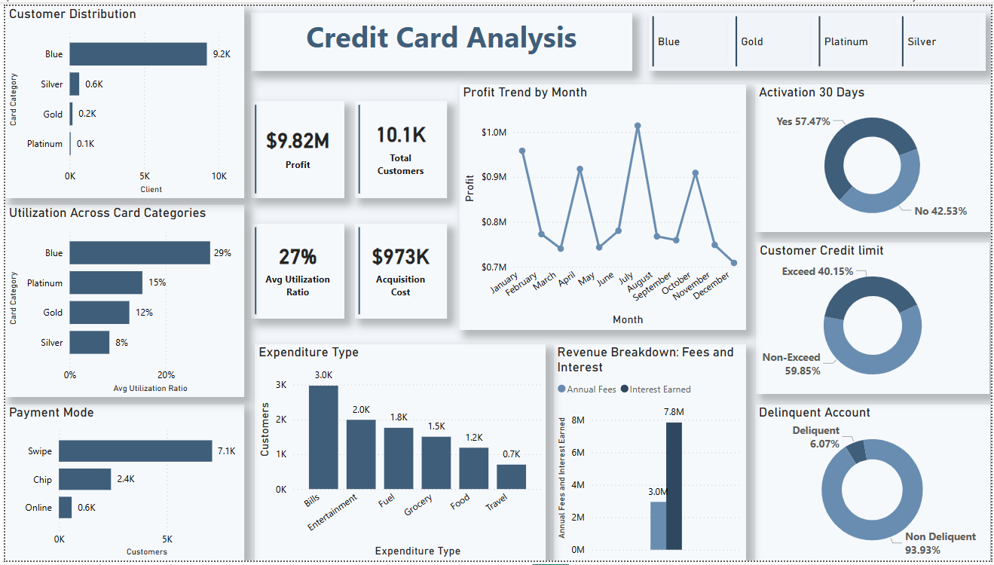

* **Customer Base:** The **Blue card dominates** in user count **(91%)**, but Platinum and Gold customers contribute more to revenue.

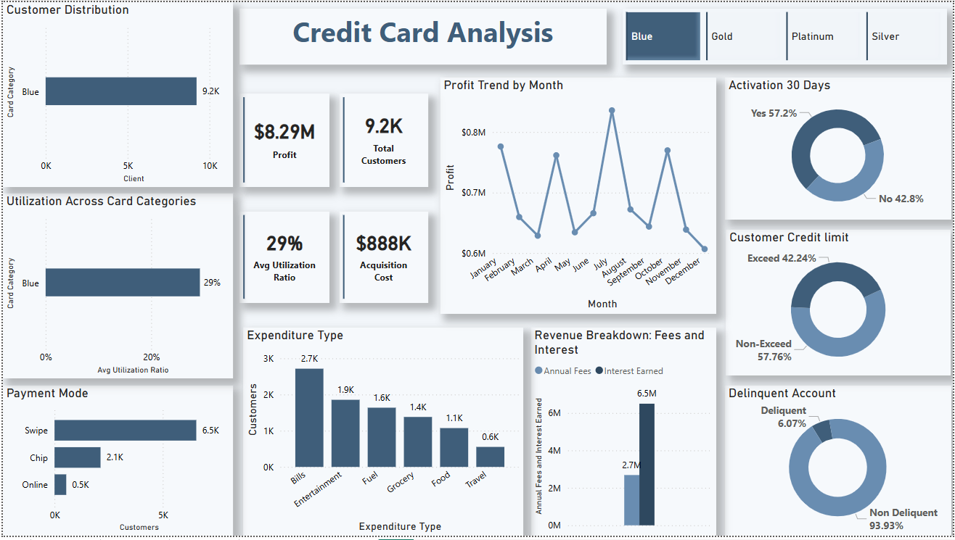

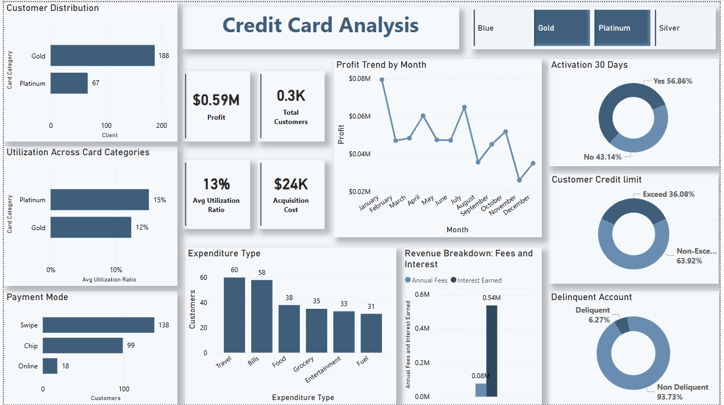

* **Card Utilization:** **Blue** cardholders have the **highest utilization rate** **(29%)**, while **Platinum** users spend **more per transaction**.

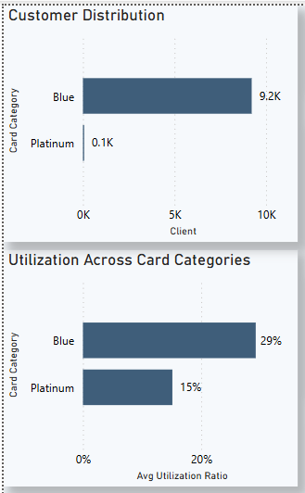

* **Spending Patterns**:

**Overall:** Bills and entertainment are the top spending categories, while travel and food have the lowest spending.

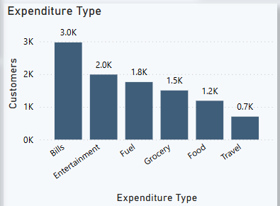

**By Card Category:**

* **Blue & Silver Cards:** Bills and entertainment have the highest spending.

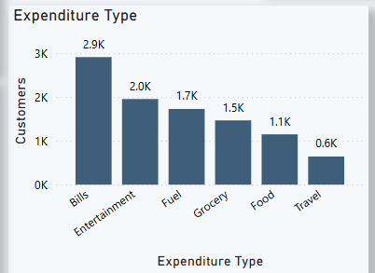

* **Gold Card:** Bills and travel are the top spending categories.

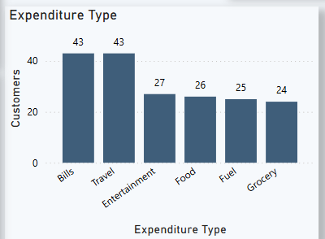

* **Platinum Card:** Travel and bills have the highest spending.

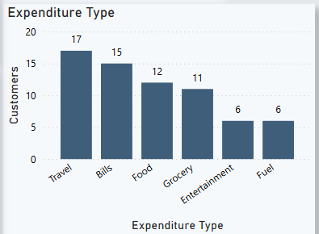

* **Payment Methods:** Swipe is the most used method (**70.25%)**; online payments are underutilized **(5.87%)**.

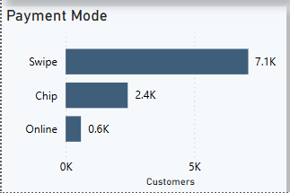

* **Platinum card** users prefer the **Chip method (49.25%)**, followed by **Swipe (44.78%)**. **Online** payments remain underutilized **(5.97%)**.

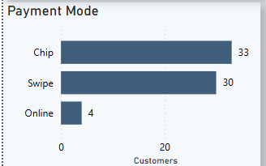

* **Credit Limit:** **Overall, 40.15%** of customers exceed their credit limits. Among card types, **Platinum** users have the **highest exceed rate (53.73%)**, followed by **Blue (42.24%), Gold (29.79%), and Silver (11.58%)**.

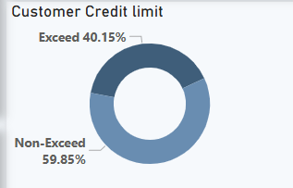

* **Delinquency:** Higher-tier cards (Gold & Platinum) have lower delinquency rates, while lower-tier cards (Blue & Silver) have more late payments.
* The delinquency rate is highest among **Blue** card users (**6.7%)**, followed by **Gold (6.38%), Silver (6.1%), and Platinum (5.97%)**

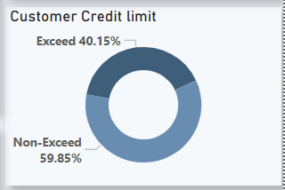

* **Activation Rate:** The **activation rate** within the first **30 days** stands at **57.47%,** while **42.53%** of new customers **fail** to activate their cards within this period, highlighting a need for strategies to encourage early card usage.

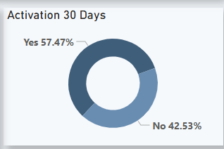

# Dashboard Overview



**Key Metrics:**

* Profit: $9.82M
* Total Customers: 10.1K
* Average Utilization: 27%
* Acquisition Cost: $973K

**Visualizations:**

* Customer Distribution by Card Type
* Utilization Ratio Across Cards
* Profit Trend by Month
* Payment Mode Analysis
* Activation Rate (30 Days)
* Revenue Breakdown
* Expenditure Type Analysis
* Credit Limit Compliance
* Delinquency Tracking

**Interactivity:**

* Filters for card types and months

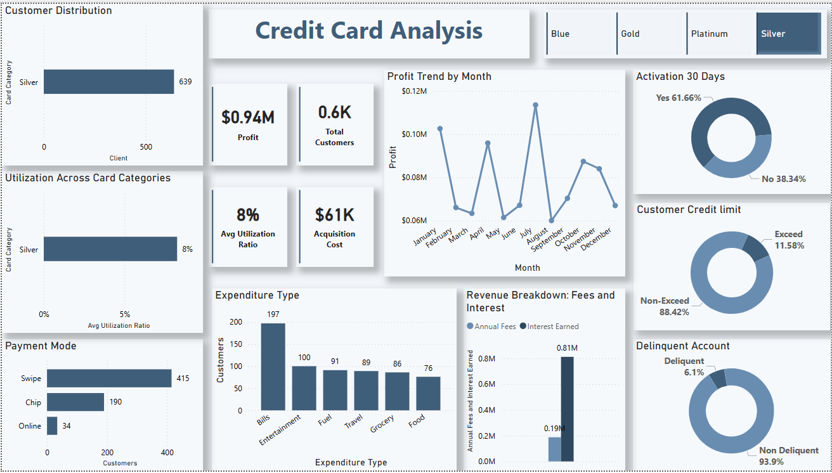

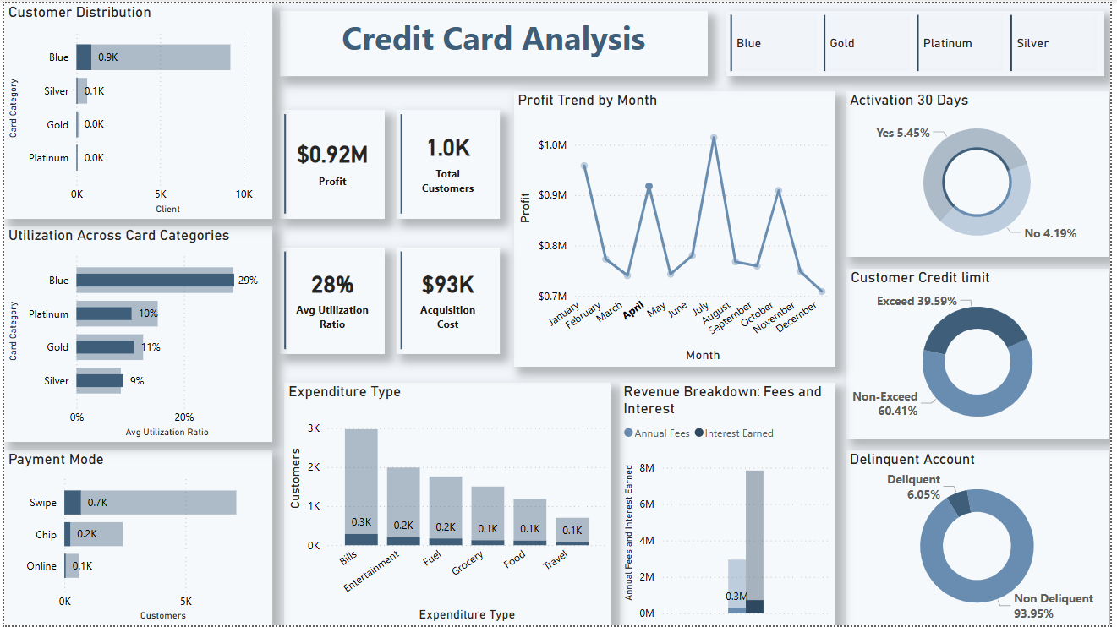

* Visuals respond dynamically to selections for deeper analysis

# Conclusion

**Insights**

* **Gold** and **Platinum** users bring in **more revenue**, though **Blue** cards have **91%** of users.
* **Blue** cardholders use **29%** of their credit and have the **highest delinquency** rate at **6.7%.**
* **Platinum** and **Gold** users spend more on **travel**; **Blue** and **Silver** spend mostly on **bills** and **entertainment**.
* **70.25%** of payments are made by **swipe**; only **5.87%** are **online**.
* **Platinum** users prefer **chip** payments **(49.25%).**
* **40.15%** of users **exceed** their **credit limits**; **highest** among **Platinum** **(53.73%).**
* **Blue** and **Silver** users have more **late payments** than Gold and Platinum.
* **42.53%** of new users **don’t activate** their cards within **30 days**.

**Recommendations**

* **Focus on Gold and Platinum users** with premium offers and loyalty programs to boost revenue.
* **Monitor Blue cardholders closely**, as high credit use (29%) and a 6.7% delinquency rate show higher risk—consider lower limits or alerts.
* **Offer travel rewards and benefits** to Gold and Platinum users; provide practical bill-related offers for Blue and Silver users.
* **Encourage online payments** by offering cashback or discounts to reduce reliance on swiping (currently 70.25%).
* **Highlight security features** of online and contactless payments to build trust, especially for Platinum users who favor chip use (49.25%).
* **Set usage alerts and reminders** for users who often exceed their credit limits—especially Platinum users (53.73%).
* **Provide payment reminders or flexible plans** for Blue and Silver users to reduce late payments.
* **Run activation campaigns** (like welcome bonuses) to encourage early usage, since 42.53% of new users delay activation.

**Future Improvements**

* **Real-time data updates** for more accurate and timely insights.
* **Better customer segmentation** to offer personalized rewards and services.
* **Use predictive analytics** to forecast spending behaviour and credit risk early.
* **Deeper analysis of credit utilization** to spot unusual or risky spending habits.
* **Track customer retention** by analysing long-term usage and engagement.
* **Add time-based comparisons** to see how performance changes month-to-month or year-to-year.

# Appendix

**Data Source & Preparation**

* **Source**: CSV dataset from professor
* **Cleaning** **Steps:**
  + Removed duplicates and handled missing values
  + Standardized formats and corrected data types
  + Created new columns for credit exceedance and profit metrics

**Visuals Used**

* Bar & pie charts (customer distribution, expenditure)
* Line charts (monthly trends)
* Heatmaps (utilization & delinquency)
* Slicers (filters for interactivity)

**Challenges & Solutions**

* Missing/Duplicate Data: Cleaned and standardized
* Data Type Errors: Converted formats for accurate calculations
* DAX Formula Bugs: Refined profit, utilization, and flag formulas
* Interactivity Issues: Ensured visual consistency and dynamic updates
* Visual Clarity: Improved labelling and formatting